**AMERICAN INTERNATIONAL UNIVERSITY BANGLADESH**

**Faculty of Engineering**

**Laboratory Report Cover Sheet**

***Students must complete all details except the faculty use part.***

Please submit all reports to your subject supervisor or the office of the concerned faculty.

**Lab Title:** Deriving logic equations and truth table from a given statement or expression and construction of combinational circuits.

Experiment Number: **01** Due Date: 11/102023 Semester: Fall 2022-2023__

Subject Code: **EEE3102** Subject Name: DIGITAL LOGIC AND CIRCUITS LABSection: **_L_**

Course Instructor: **NUZAT NUARY ALAM** Degree Program: **B.Sc. CSE**

**Declaration and Statement of Authorship:**

1. I/we hold a copy of this report, which can be produced if the original is lost/ damaged.
2. This report is my/our original work and no part of it has been copied from any other student’s work or from any other source except where due acknowledgement is made.
3. No part of this report has been written for me/us by any other person except where such collaboration has been authorized by the lecturer/teacher concerned and is clearly acknowledged in the report.
4. I/we have not previously submitted or currently submitting this work for any other course/unit.
5. This work may be reproduced, communicated, compared and archived for the purpose of detecting plagiarism.
6. I/we give permission for a copy of my/our marked work to be retained by the school for review and comparison, including review by external examiners.

**I/we understand that**

1. Plagiarism is the presentation of the work, idea or creation of another person as though it is your own. It is a form of cheating and is a very serious academic offence that may lead to expulsion from the University. Plagiarized material can be drawn from, and presented in, written, graphic and visual form, including electronic data, and oral presentations. Plagiarism occurs when the origin of the material used is not appropriately cited.
2. Enabling plagiarism is the act of assisting or allowing another person to plagiarize or to copy your work.

|  |  |  |  |  |  |  |  |  |  |  |
| --- | --- | --- | --- | --- | --- | --- | --- | --- | --- | --- |
|  | Group Number (if applicable): 6 | | | Individual Submission | | | Group Submission | |  |  |
|  |  |  |  |  |  |  |  |  |  |  |
|  |  |  |  |  |  |  |  |  |  |  |
|  | **No.** |  | **Student Name** |  |  | **Student Number** | **Student Signature** | **Date** |  |  |
|  | **Submitted by:** | |  |  |  |  |  |  |  |  |
|  |  |  |  |  |  |  |  |  |  |  |
| **1** | |  | **Rudro Shine Datta** |  |  | **22-46723-1** |  | 11/10/2023 |  |  |
|  |  |  |  |  |  |  |  |  |  |  |
|  | **Group Members:** | |  |  |  |  |  |  |  |  |
|  |  |  |  |  |  |  |  |  |  |  |
| **2** | |  |  |  |  |  |  |  |  |  |
|  |  |  |  |  |  |  |  |  |  |  |
| **3** | |  |  |  |  |  |  |  |  |  |
|  |  |  |  |  |  |  |  |  |  |  |
| **4** | |  |  |  |  |  |  |  |  |  |
|  |  |  |  |  |  |  |  |  |  |  |
| **5** | |  |  |  |  |  |  |  |  |  |
|  |  |  |  |  |  |  |  |  |  |  |
|  |  | |  |  |  |  |  |  |  |  |
|  | ***For faculty use only:*** | |  |  |  | **Total Marks: _______ Marks Obtained: _______** | | |  |  |
|  |  |  |  |  |  |  |  |
|  |  |  |  |  |  |  |  |  |  |  |



**Faculty comments**___________________________________________________________________________

___________________________________________________________________________________________

# Title: Deriving logic equations and truth table from a given statement or expression and construction of combinational circuits

**Abstract:**

This experiment is designed to-

1. Help students implement the logic circuits derived from a given statement in the breadboard using gate ICs and observe whether the output verifies the truth table of the given logic statement or not.
2. Perform relevant theoretical work by deriving the logic circuit and truth table from the given logic equation/statement and get familiarized with Boolean algebra and De Morgan’s law.
3. Simplify the logic expressions with K-Map and verify accuracy by breadboard implementation.

**Introduction:**

From any given logic statement, it is possible to construct a digital logic circuit. The first step in this process is to construct a truth table and then determine a standard SOP (sum of products) or POS (product of sums). At the same time, it is also possible to derive a logic expression from a given combinational circuit diagram by observing the individual logic operations performed in the circuit and matching them with their corresponding logic gates. Expressions are simplified using Boolean algebra and De Morgan's law or K-Map to reduce the number of gates used. Then the circuit is implemented in the breadboard using gate ICs and observed whether the output verifies the truth table of the given statement.

This experiment shows the students a practical verification of deriving logic equations and truth table from combinational circuits. Knowing how to derive logic equations and truth table from combinational circuits helps a person with detecting the output logic expressions from any unknown logic circuit.

**Theory and Methodology:**

Combinational circuits are built with logic gates and other components. It does not include any values to be taken from a previous state of the circuit. Designing such a combinational digital system requires use of one of the following methods:

* 1. If a problem statement is given, the following steps will help designing the system

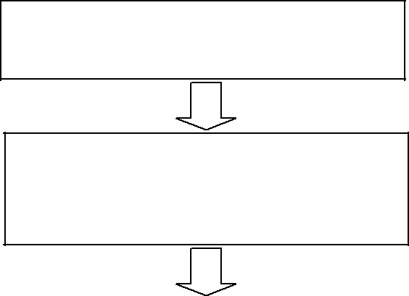

Look for the problem statement

Find the input(s) and output(s) of the

system and relate the input(s) with the output(s)

Develop a truth table for your system using the input and output relationship that you have established

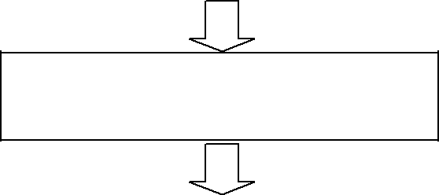

From your truth table, generate a

standard output expression

Reduce/simplify the output expression

using Boolean algebra or K-Map

Implement the circuit using the simplified Boolean expression.

* 1. Or if an expression is given, the following steps will help in designing the system



If the provided expression is not

standard, make it standard

After standardization, create a truth-

table.



Use the truth-table to develop a K-

MAP

Use proper grouping in K-MAP in

determining the output expression.

Use the reduced expression for combinational circuit design.

Some useful definitions related to these procedures are given below:

**Boolean algebra:** In Boolean algebra, a variable is a symbol used to represent an action, a condition, or data. A single variable can only have a value of 1 or 0.

1. **Variable:** A symbol used to represent a logical quantity that can have a value of 1 or 0, usually designated by an italic letter.
2. **Complement:** The inverse or opposite of a number. In Boolean algebra, the inverse function, expressed with a bar over the variable.
3. **Sum term:** The Boolean sum of two or more literals equivalent to an OR operation
4. **Product term:** The Boolean product of two or more literals equivalent to an AND operation.

# Sum of Products (SOP):

When two or more product terms are summed by boolean addition, the resulting expression is a sum of product. Ex.

Implementing an SOP expression simply requires ORing the outputs of two or more AND gates. A product term is produced by an AND operation, and the sum (addition) of two or more product terms is produced by an OR operation. Therefore, an SOP expression can be implemented by AND-OR logic in which the outputs of a number (equal to the number of product terms in the expression) of AND gates connect to the inputs of an OR gate.

A standard SOP expression is one in which all the variables in the domain appear in each product term. Ex.

Standard SOP expressions are important in constructing truth-tables and in Karnaugh map simplification method.

The SOP expression is equal to 1 only if one or more of the product terms in the expression is equal to 1.

# Product of Sums (POS):

When two or more sum terms are multiplied, the resulting expression is a product of sums (POS). Ex.

Implementing a POS expression simply requires ANDing the outputs of two or more OR gates. A sum term is produced by an OR operation, and the product of two or more sum terms is produced by an AND operation. Therefore, a POS expression can be implemented by logic in which the outputs of a number (equal to the number of sum terms in the expression) of OR gates connect to the inputs of an AND gate.

A standard POS expression is one in which all the variables in the domain appear in each sum term in the expression. Ex.

A POS expression is equal to 0 only if one or more of the sum terms in the expression is equal to 0.

# Karnaugh Map:

A Karnaugh map provides a systematic method for simplifying Boolean expressions and, if properly used, will produce the simplest SOP or POS expression possible le, known as the minimum expression.

A Karnaugh map is similar to a truth table because it presents all of the possible values of input variables and the resulting output of each valued. Instead of being organized into columns and rows like truth table, the Karnaugh map is an array of cells in which each cell presents binary value of the input variables. The cells are arranged in a way so that the simplification of a given expression is simply a matter of properly grouping the cells. Karnaugh maps can be used for expressions with two, three, four and five variables. The number of cells in a Karnaugh map is

equal to the total number of possible input variable combinations as is the number of rows in a truth table.

**Problem1.** A Building has 4 floors which share the same water tank for water supply. In order to start the motor, each floor has a designated switch- Ground Floor with switch A, 1st Floor with switch B, 2nd Floor with switch C and 3rd Floor with switch D. The motor starts if someone presses the switch from the 3rd floor or from both ground and 2nd floor or from 1st and 2nd floor. Your job is to design the system.

**Problem2.** For the expression ***(AB+AC)’+ A’B’C,*** find the truth-table and the logic gate diagram, reduced expression using K-MAP.

**Pre-Lab Homework:** Students must study the Boolean algebra rules and De Morgan’s Law. They should also study how to derive truth table from logic expressions. They need to perform simulation of the circuits shown in the circuit diagram sections using PSIM and MUST present the simulation results to the instructor before the start of the experiment.

# Apparatus:

* 1. Digital trainer board 2. IC 7432:1 pcs

3. IC 7408:1 pcs

4. IC 7404:2 pcs

5. IC 7402:1 pcs

6. IC 7400:1 pcs

7. IC 7486:1 pcs

8. Connecting wires

**Precaution:** The IC contains protection circuitry to guard against damage due to high static voltages or electric fields. However, precautions must be taken to avoid applications of any

voltage higher than maximum rated voltages. For proper operation, Vin and Vout should be

constrained to the range GND to VCC. Connect the ICs according to their pin configuration carefully and use connecting the wires with the ICs to make sure that they are firmly connected. Check whether all the data switches and output showing LEDs are working.

# Experimental Procedure:

**Problem1:**

**Truth table:**

|  |  |  |  |  |
| --- | --- | --- | --- | --- |
| A | B | C | D | Y |
| 0 | 0 | 0 | 0 | 0 |
| 0 | 0 | 0 | 1 | 1 |
| 0 | 0 | 1 | 0 | 0 |
| 0 | 0 | 1 | 1 | 1 |
| 0 | 1 | 0 | 0 | 0 |
| 0 | 1 | 0 | 1 | 1 |
| 0 | 1 | 1 | 0 | 1 |
| 0 | 1 | 1 | 1 | 1 |
| 1 | 0 | 0 | 0 | 0 |
| 1 | 0 | 0 | 1 | 1 |
| 1 | 0 | 1 | 0 | 1 |
| 1 | 0 | 1 | 1 | 1 |
| 1 | 1 | 0 | 0 | 0 |
| 1 | 1 | 0 | 1 | 1 |
| 1 | 1 | 1 | 0 | 1 |
| 1 | 1 | 1 | 1 | 1 |

**K-Map:**

CD

|  |  |  |  |  |
| --- | --- | --- | --- | --- |
| AB | 00 | 01 | 11 | 10 |
| 00 | 0 | 1 | 1 | 0 |
| 01 | 0 | 1 | 1 | 1 |
| 11 | 0 | 1 | 1 | 1 |
| 10 | 0 | 1 | 1 | 1 |

**Simplified Boolean Expression:**

Y = AC + BC + D

# Simulation and Measurement:

|  |  |
| --- | --- |
| **Simulations** | **Hardware** |
| A=0, B=0, C=0, D=0 | A=0, B=0, C=0, D=0 |
| A=0, B=0, C=0, D=1 | A=0, B=0, C=0, D=1 |
| A=0, B=0, C=1, D=0 | A=0, B=0, C=1, D=0 |
| A=0, B=0, C=1, D=1 | A=0, B=0, C=1, D=1 |
| A=0, B=1, C=0, D=0 | A=0, B=1, C=0, D=0 |
| A=0, B=1, C=0, D=1 | A=0, B=1, C=0, D=1 |
| A=0, B=1, C=1, D=0 | A=0, B=1, C=1, D=0 |
| A=0, B=1, C=1, D=1 | A=0, B=1, C=1, D=1 |
| A=1, B=0, C=0, D=0 | A=1, B=0, C=0, D=0 |
| A=1, B=0, C=0, D=1 | A=1, B=0, C=0, D=1 |
| A=1, B=0, C=1, D=0 | A=1, B=0, C=1, D=0 |
| A=1, B=0, C=1, D=1 | A=1, B=0, C=1, D=1 |
| A=1, B=1, C=0, D=0 | A=1, B=1, C=0, D=0 |
| A=1, B=1, C=0, D=0 | A=1, B=1, C=0, D=0 |
| A=1, B=1, C=1, D=0 | A=1, B=1, C=1, D=0 |
| A=1, B=1, C=1, D=1 | A=1, B=1, C=1, D=1 |

# Problem2:

# Given Expression:

$$\overline{\left(AB+AC\right)}+ \overline{A}\overline{B}C$$

# = $\overline{AB} \overline{AC}+\overline{A}\overline{B}C$

# = $\left(\overline{A}+ \overline{B}\right)+ \left(\overline{A}+ \overline{C}\right)+ \overline{A}\overline{B}C$

# = $\overline{A}+ \overline{A}\overline{C}+ \overline{A}\overline{B}+ \overline{B}\overline{C}+ \overline{A}\overline{B}C$

# = $\overline{A}BC+ \overline{A}B\overline{C}+ \overline{A}\overline{B}C+ \overline{A}\overline{B}\overline{C}+ \overline{A}\overline{B}C+ \overline{A}B\overline{C}+ A\overline{B}\overline{C}+ \overline{A}\overline{B}C+ \overline{A}\overline{B}\overline{C}+ A\overline{B}\overline{C}+ \overline{A}\overline{B}\overline{C}+ A\overline{B}\overline{C}$

# = $\overline{A}BC+ \overline{A}B\overline{C}+ \overline{A}\overline{B}C+ \overline{A}\overline{B}\overline{C}+ A\overline{B}\overline{C}$

# SOP: $\overline{A}BC+ \overline{A}B\overline{C}+ \overline{A}\overline{B}C+ \overline{A}\overline{B}\overline{C}+ A\overline{B}\overline{C}$

# Truth Table:

|  |  |  |  |  |
| --- | --- | --- | --- | --- |
| A | B | C | Y | Min-Term |
| 0 | 0 | 0 | 1 | $$\overline{A}\overline{B}\overline{C}$$ |
| 0 | 0 | 1 | 1 | $$\overline{A}\overline{B}C$$ |
| 0 | 1 | 0 | 1 | $$\overline{A}B\overline{C}$$ |
| 0 | 1 | 1 | 1 | $$\overline{A}BC$$ |
| 1 | 0 | 0 | 1 | $$A\overline{B}\overline{C}$$ |
| 1 | 0 | 1 | 0 | $$A\overline{B}C$$ |
| 1 | 1 | 0 | 0 | $$AB\overline{C}$$ |
| 1 | 1 | 1 | 0 | $$ABC$$ |

# K-Map:

|  |  |  |
| --- | --- | --- |
| C  AB | 0 | 1 |
| 00 | 1 | 1 |
| 01 | 1 | 1 |
| 11 | 0 | 0 |
| 10 | 1 | 0 |

# Simplified SOP: $Y =\overline{A}+ \overline{B}\overline{C}$

# Simulation and Measurement:

|  |  |
| --- | --- |
| A=0, B=0, C=0 | A=0, B=0, C=0 |
| A=0, B=0, C=1 | A=0, B=0, C=1 |
| A=0, B=1, C=0 | A=0, B=1, C=0 |
| A=0, B=1, C=1 | A=0, B=1, C=1 |
| A=1, B=0, C=0 | A=1, B=0, C=0 |
| A=1, B=0, C=1 | A=1, B=0, C=1 |
| A=1, B=1, C=0 | A=1, B=1, C=0 |
| A=1, B=1, C=1 | A=1, B=1, C=1 |

# Results and Discussion:

Students will implement the circuit in the Trainer Board and match the theoretically obtained truth table by matching outputs for individual input configurations. If the practically obtained truth table does not match, they will also investigate the errors.

Students will summarize the experiment and discuss it as a whole. They will observe that the method of deriving logic equations and truth tables is valid and effective. They will also see whether they can make the circuit efficient by reducing the number of gates used. They will also include any limitations of the process. If the connection is not loose, gates are properly biased, all the output LEDs are working and the ICs that are being used are not broken; and then the practically obtained truth table should exactly match the theoretical one. Which will, in turn validate the process.

# Report Questions:

1. (i) Equation: Y = AC + BC + D

# Simulation and Measurement (Using NAND Gate):

# 

# A=0, B=0, C=0, D=0 A=0, B=0, C=0, D=1

# 

A=0, B=0, C=1, D=0 A=0, B=0, C=1, D=1

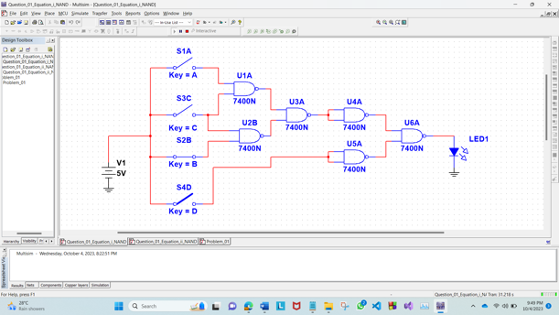 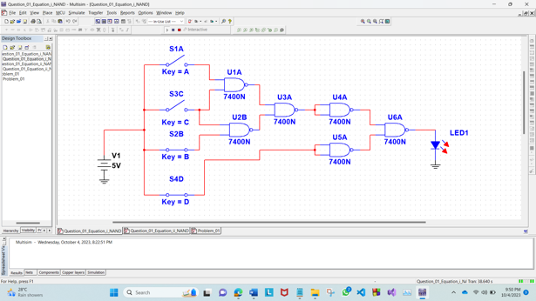

A=0, B=1, C=0, D=0 A=0, B=1, C=0, D=1

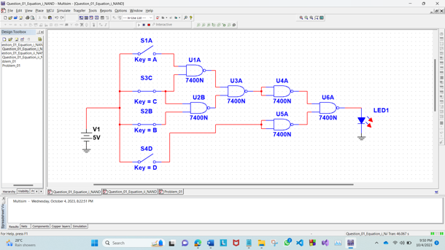 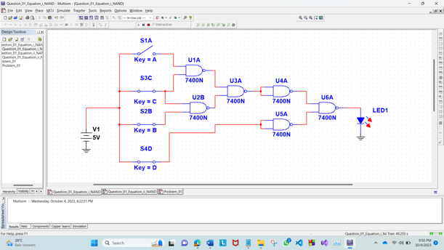

A=0, B=1, C=1, D=0 A=0, B=1, C=1, D=1

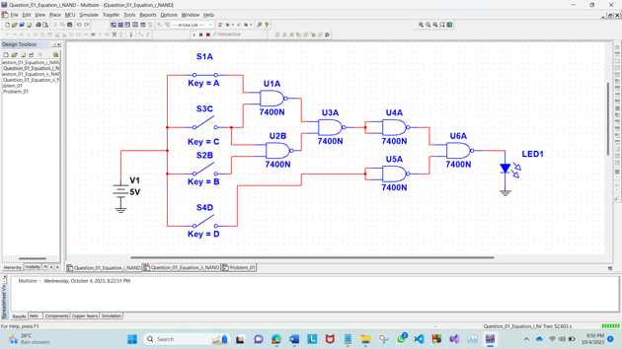 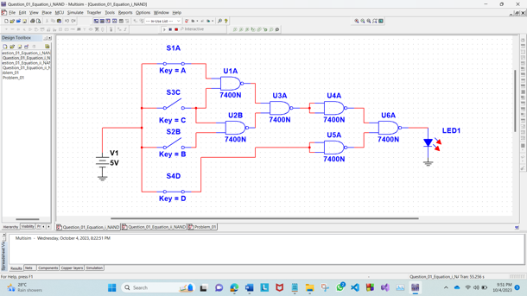

A=1, B=0, C=0, D=0 A=1, B=0, C=0, D=1

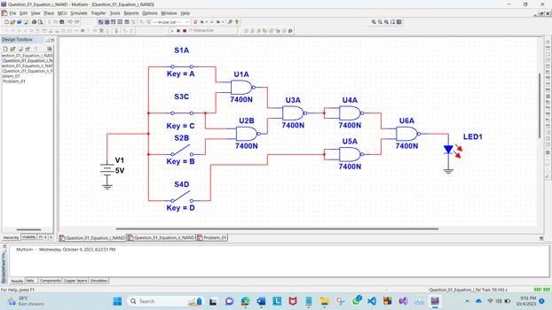 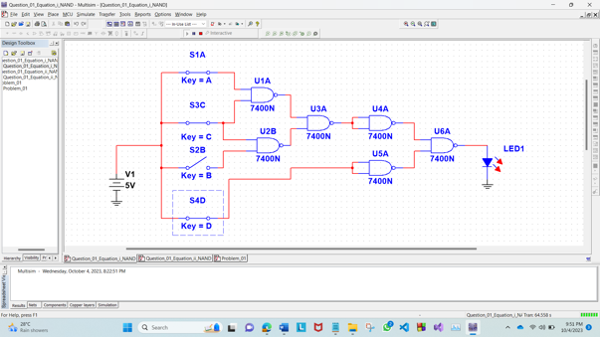

A=1, B=0, C=1, D=0 A=1, B=0, C=1, D=1

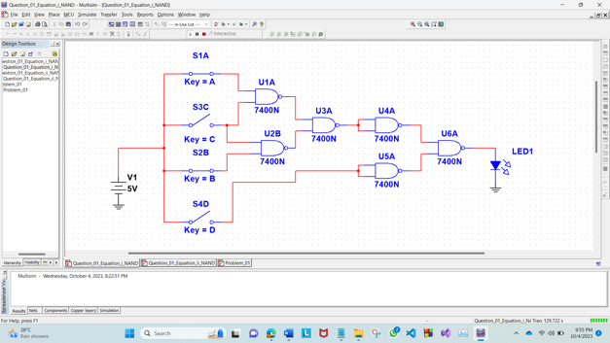 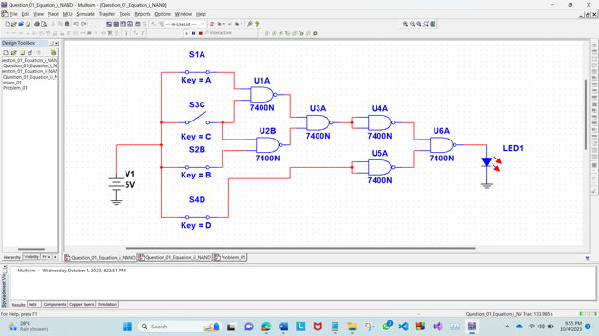

A=1, B=1, C=0, D=0 A=1, B=1, C=0, D=1

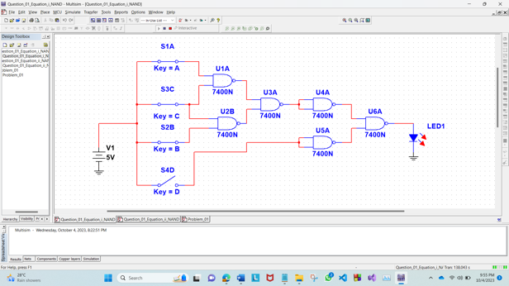 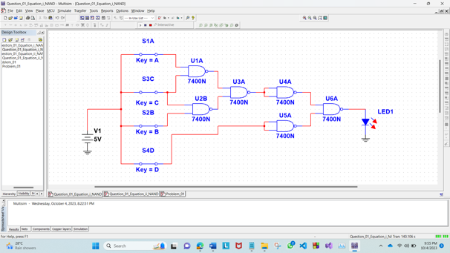

A=1, B=1, C=1, D=0 A=1, B=1, C=1, D=1

# Simulation and Measurement (Using NOR Gate):

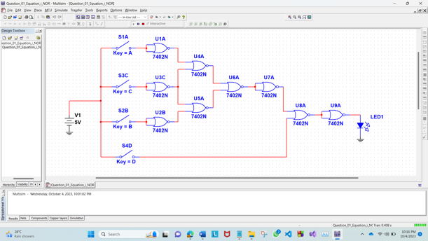 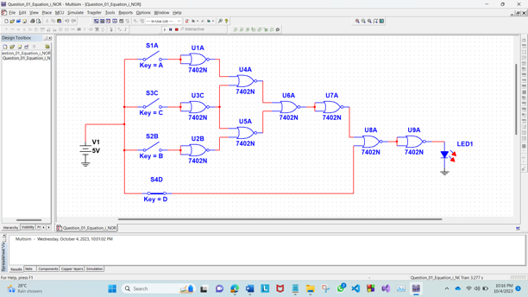

A=0, B=0, C=0, D=0 A=0, B=0, C=0, D=1

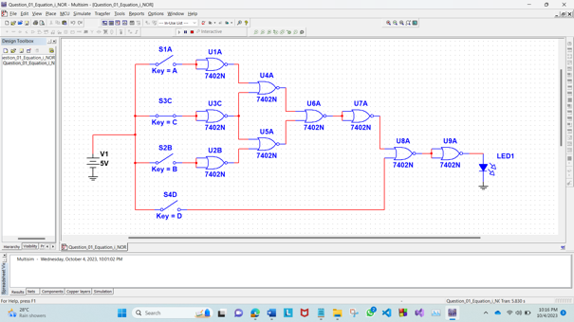 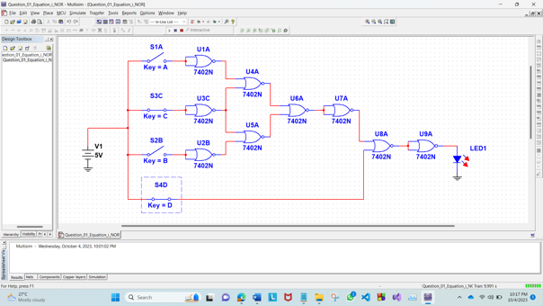

A=0, B=0, C=1, D=0 A=0, B=0, C=1, D=1

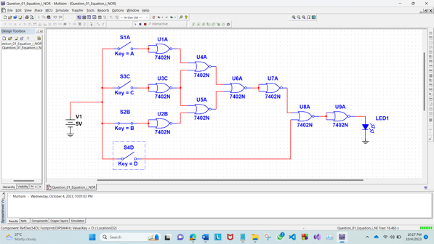 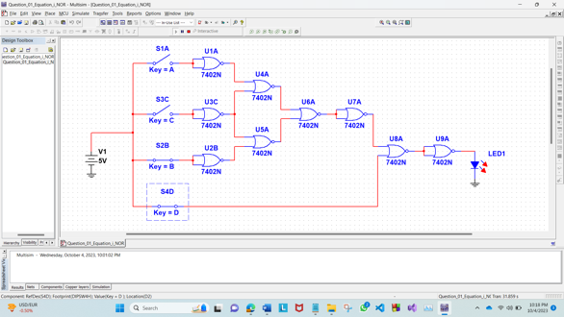

A=0, B=1, C=0, D=0 A=0, B=1, C=0, D=1

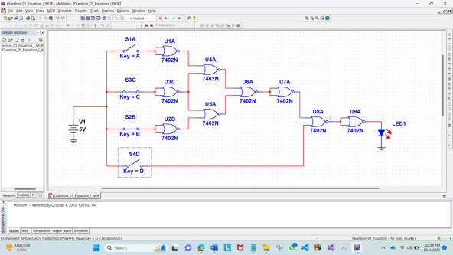 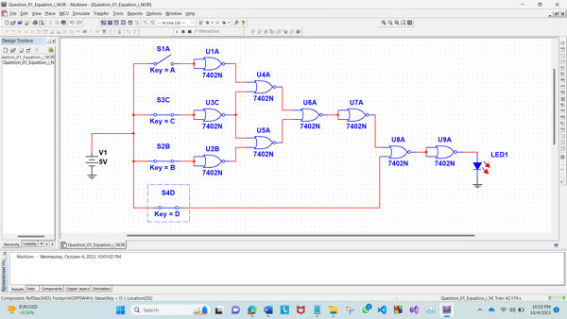

A=0, B=1, C=1, D=0 A=0, B=1, C=1, D=1

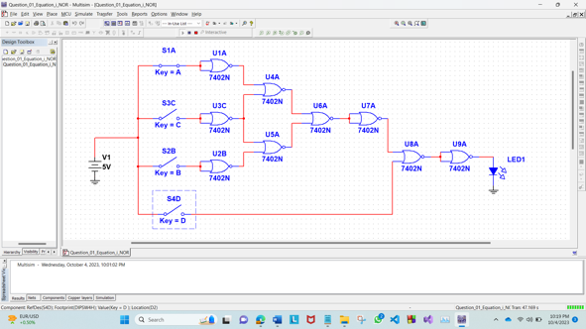 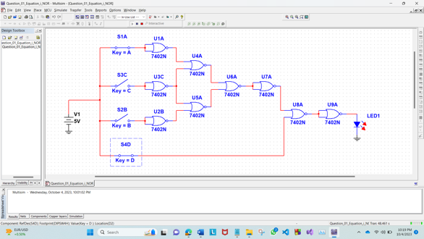

A=1, B=0, C=0, D=0 A=1, B=0, C=0, D=1

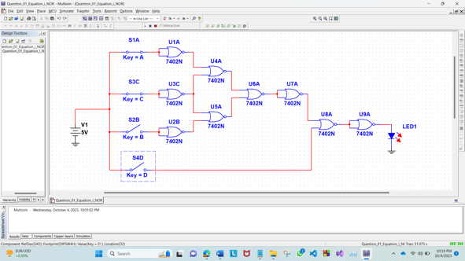 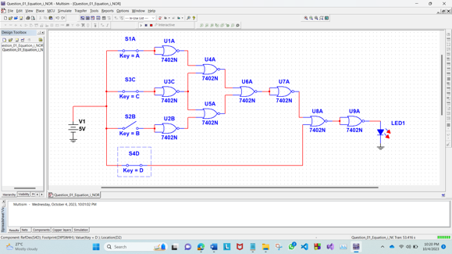

A=1, B=0, C=1, D=0 A=1, B=0, C=1, D=1

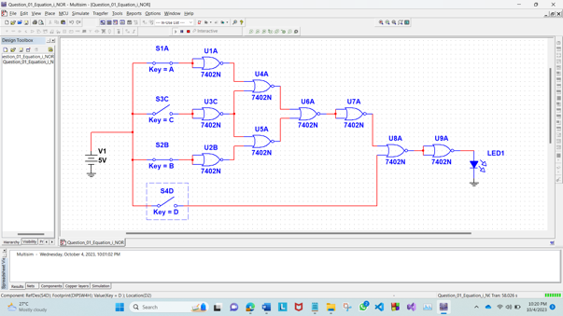 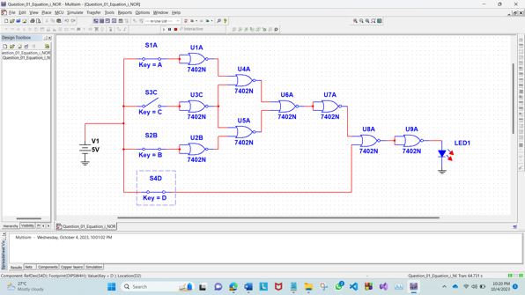

A=1, B=1, C=0, D=0 A=1, B=1, C=0, D=1

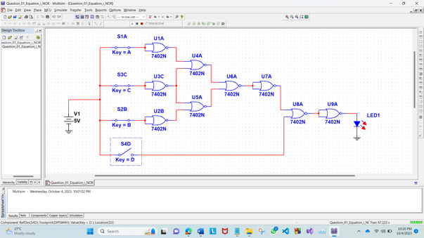 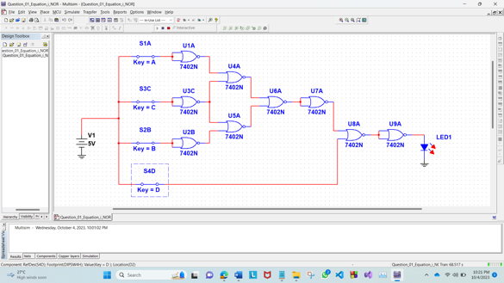

A=1, B=1, C=1, D=0 A=1, B=1, C=1, D=1

(ii) Equation: $Y =\overline{A}+ \overline{B}\overline{C}$

# Simulation and Measurement (Using NAND Gate):

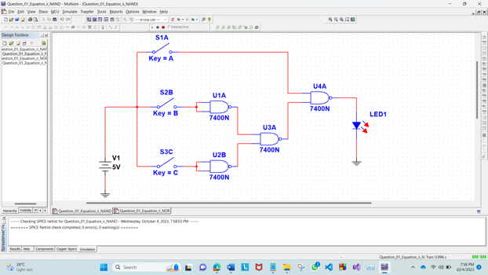 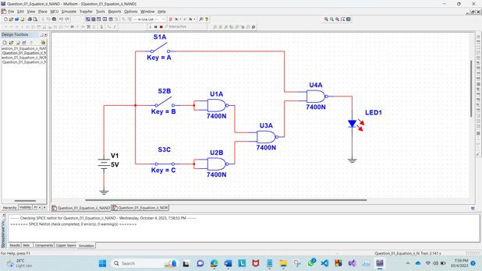

A=0, B=0, C=0 A=0, B=0, C=1

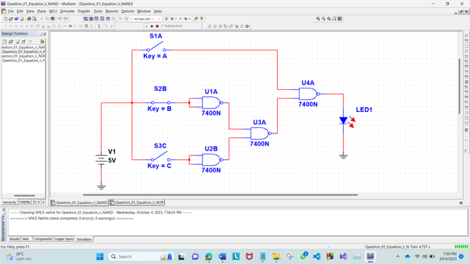 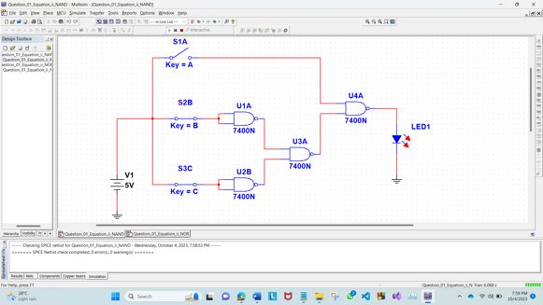

A=0, B=1, C=0 A=0, B=1, C=1

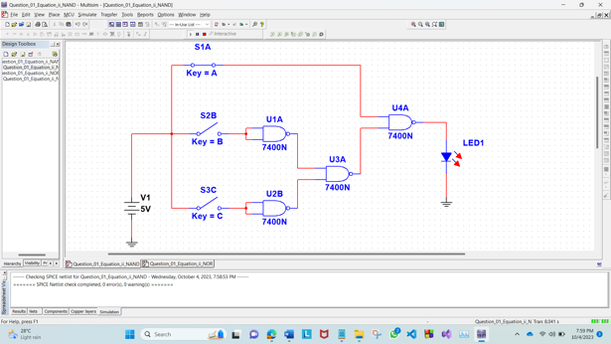 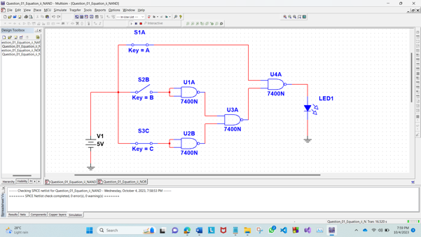

A=1, B=0, C=0 A=1, B=0, C=1

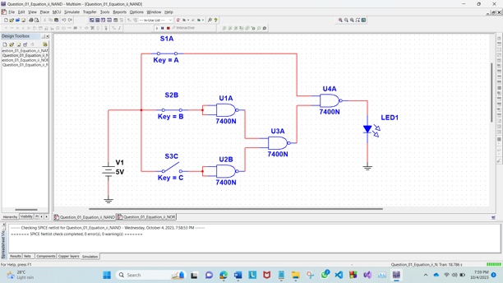 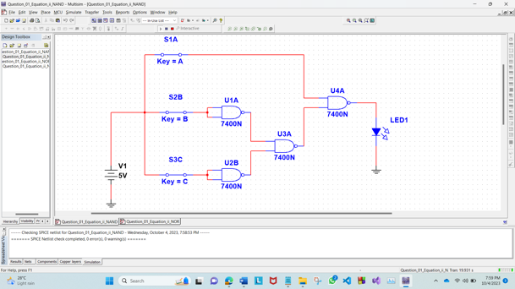

A=1, B=1, C=0 A=1, B=1, C=1

# Simulation and Measurement (Using NOR Gate):

# 

A=0, B=0, C=0 A=0, B=0, C=1

# 

A=0, B=1, C=0 A=0, B=1, C=1

# 

A=1, B=0, C=0 A=1, B=0, C=1

# 

A=1, B=1, C=0 A=1, B=1, C=1

**2. Given expression:**

$$ABC+\overline{AB}C+\overline{A}BC+A\overline{B}C+A\left(\overline{B}+C\right) \\ =ABC+\overline{AB}C+\overline{A}BC+A\overline{B}C+A\overline{B}+AC \\ =BC\left(A+\overline{A}\right)+A\overline{B} \left(C+1\right)+AC+\overline{AB}C \\ =BC+A\overline{B}+AC+\overline{A}C+\overline{B}C \\ =C\left(B+\overline{B}\right)+C\left(A+\overline{A}\right)+A\overline{B} \\ =A\overline{B}+C$$

**Truth Table:**

|  |  |  |  |  |  |
| --- | --- | --- | --- | --- | --- |
| A | B | C | $$\overline{B}$$ | $$A\overline{B}$$ | $$A\overline{B}+C$$ |
| 0 | 0 | 0 | 1 | 0 | 0 |
| 0 | 0 | 1 | 1 | 0 | 1 |
| 0 | 1 | 0 | 0 | 0 | 0 |
| 0 | 1 | 1 | 0 | 0 | 1 |
| 1 | 0 | 0 | 1 | 1 | 1 |
| 1 | 0 | 1 | 1 | 1 | 1 |
| 1 | 1 | 0 | 0 | 0 | 0 |
| 1 | 1 | 1 | 0 | 0 | 1 |

**Simulation and Measurement:**

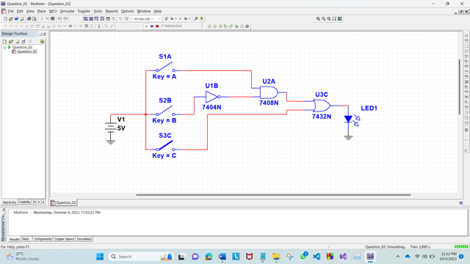 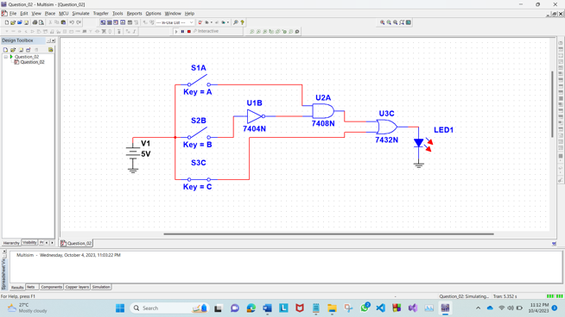

A=0, B=0, C=0 A=0, B=0, C=1

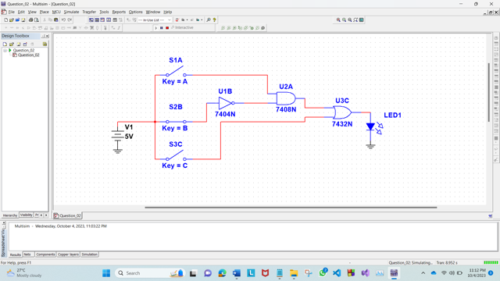 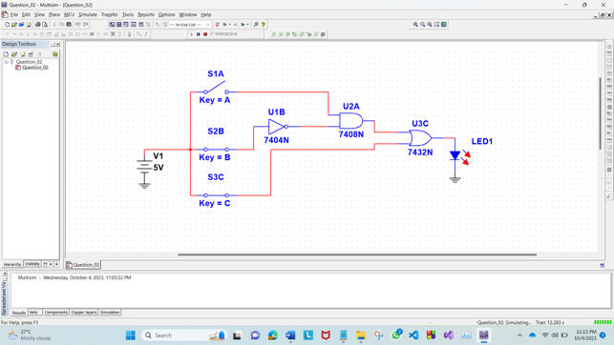

A=0, B=1, C=0 A=0, B=1, C=1

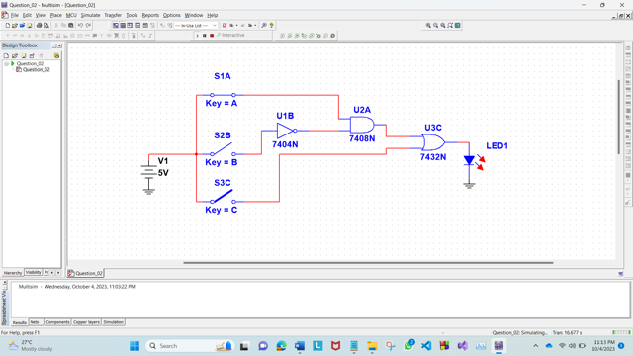 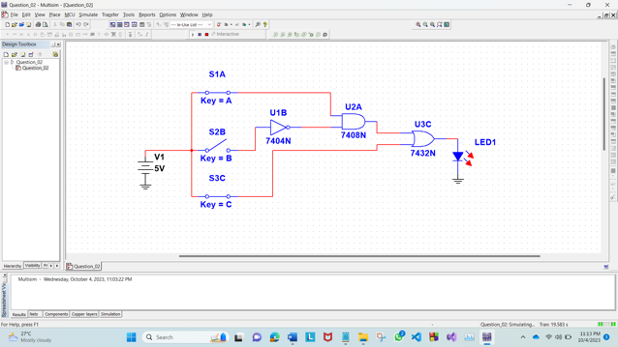

A=1, B=0, C=0 A=1, B=0, C=1

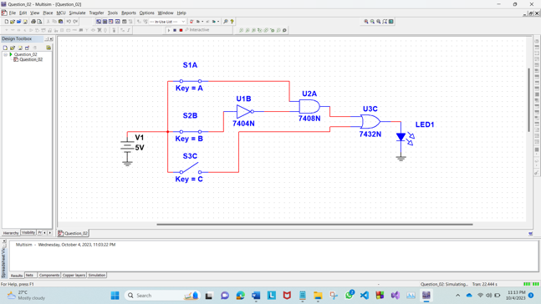 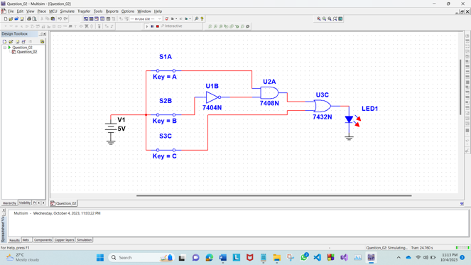

A=1, B=1, C=0 A=1, B=1, C=1

**3. Given Expression:**

ABC + AB + AC

=AB(C+1) + AC

=AB +AC

=A(B+C)

**Truth Table:**

|  |  |  |  |
| --- | --- | --- | --- |
| A | B | C | A(B+C) |
| 0 | 0 | 0 | 0 |
| 0 | 0 | 1 | 0 |
| 0 | 1 | 0 | 0 |
| 0 | 1 | 1 | 0 |
| 1 | 0 | 0 | 0 |
| 1 | 0 | 1 | 1 |
| 1 | 1 | 0 | 1 |
| 1 | 1 | 1 | 1 |

**Simulation and Measurement:**

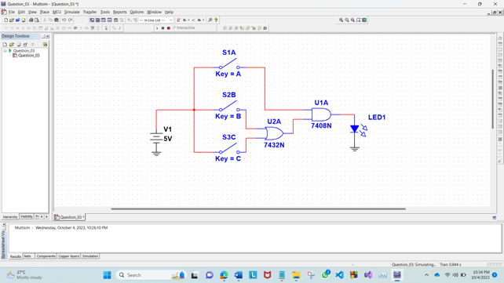 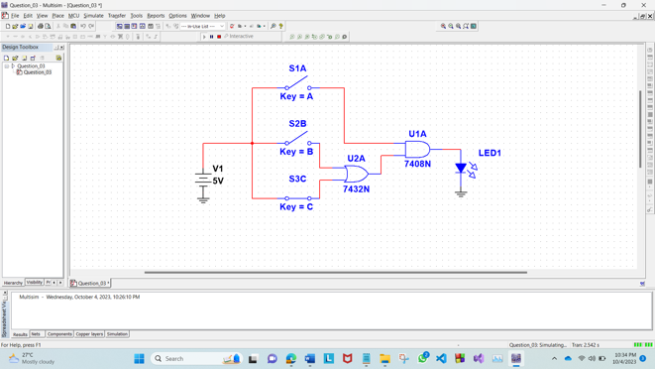

A=0, B=0, C=0 A=0, B=0, C=1

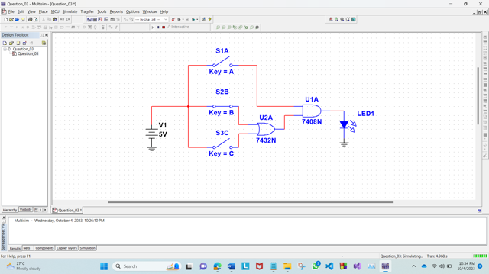 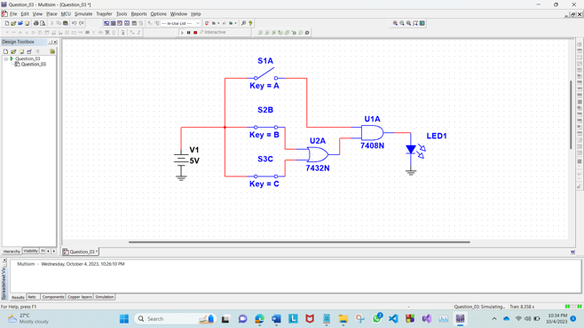

A=0, B=1, C=0 A=0, B=1, C=1

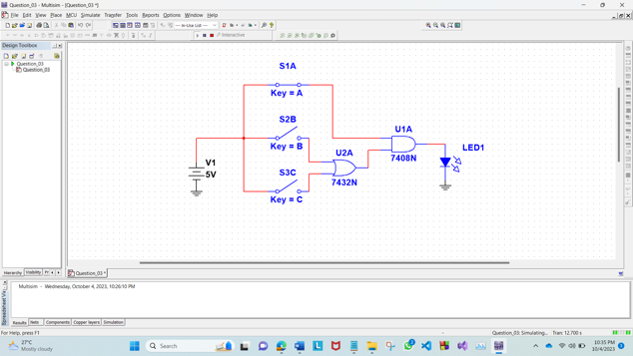 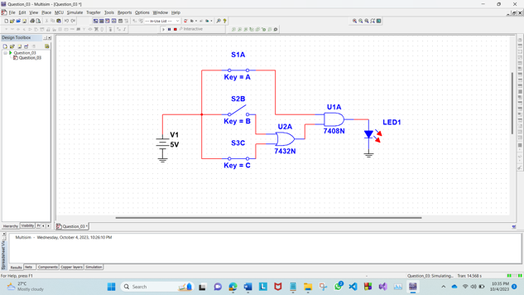

A=1, B=0, C=0 A=1, B=0, C=1

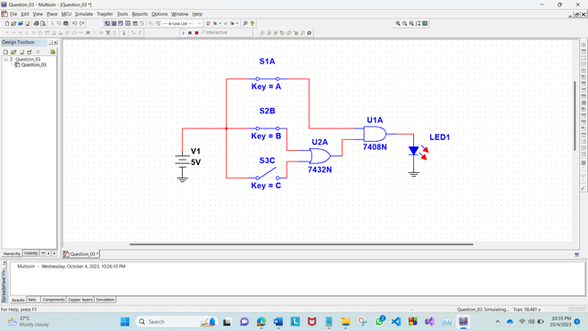 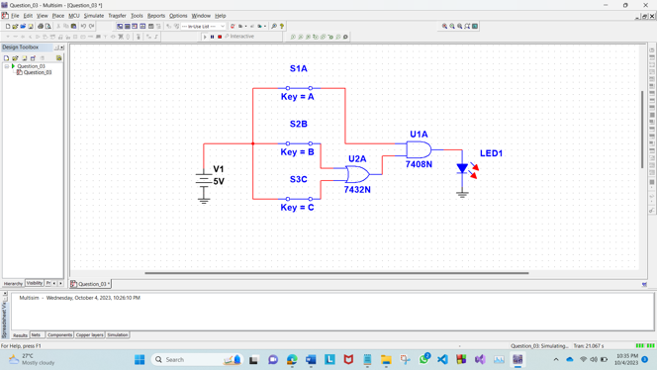

A=1, B=1, C=0 A=1, B=1, C=1

# References:

1. Thomas L. Floyd, “Digital Fundamentals”, available Edition, Prentice Hall International Inc.